Brief History
When European settlers arrived on the scene, the Bluegrass region was in use as a hunting ground for numerous Native American tribes. Daniel Boone was one of the first Anglo-Saxons to explore the area. He helped establish Kentucky's first forts in Harrodsburg and Boonesborough.
Lexington was founded in 1775, seventeen years before Kentucky became a state. William McConnell and a group of frontier explorers were camped at a natural spring when word came from nearby Fort Boonesborough that the first battle of the American Revolution had been fought in Lexington, Massachusetts. In honor of the battle, the group named their site "Lexington". By 1820, Lexington, Kentucky, was one of the largest and wealthiest towns west of the Allegheny Mountains. So cultured was its lifestyle, our city soon gained the nickname "Athens of the West."
Geography.
Fayette County consists of 283 square miles of gently rolling plateau in the center of the inner Bluegrass Region. The area is noted for its beauty, fertile soil, excellent pastureland and horse and stock farms. Poa Pratensis (bluegrass) thrives on the limestone beneath the soil's surface, playing a major role in the area's scenic beauty and in the development of champion horses. Numerous small creeks rise and flow into the Kentucky River.
Population
The latest U.S. Census estimate for Lexington-Fayette County is 295,800 (2010). The estimated population of the metropolitan statistical area (MSA), which is comprised of Bourbon, Clark, Fayette, Jessamine, Madison, Scott, and Woodford counties, is 555,000.
Climate/Seasonal Planning
The mean average temperature in Lexington is 54.9 degrees Fahrenheit. Annual precipitation is 45.68 inches. Lexington and the Bluegrass Region have four distinct seasons that include cool plateau breezes, moderate nights in the summer, and no prolonged periods of heat, cold, rain, wind, or snow.
Average minimum and maximum temperatures:
Spring: | 34-74 degrees F
Summer: | 61-86 degrees F
Fall: | 36-79 degrees F
Winter: | 23-54 degrees F

Safety.
Lexington's crime consistently ranks below the national average. In addition to foot and car patrols, the Lexington-Fayette Urban County Police Department operates two highly visible units that have proven to be effective crime deterrents. The Lexington Mounted Police Unit and Mountain Bike Unit patrol the downtown area on horseback and bicycles to help assure community safety. A survey released in 2005 by Mercer Human Resource Consulting ranked Lexington as one of the five safest cities in the United States.
Universities/Colleges in Lexington and the Region
Asbury University
Asbury Theological Seminary
Berea College
Bluegrass Community and Technical College
Centre College
Eastern Kentucky University
Georgetown College
Kentucky State University
Lexington Theological Seminary
National College of Business and Technology
Midway College
Spencerian College
Sullivan University
Transylvania University
University of Kentucky

HARLAN 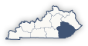 Eastern Kentucky
Located in southeastern Kentucky, Harlan is one of the oldest of Kentucky’s 120 counties. In the midst of the Appalachian coalfields and the county seat of Harlan County, Harlan is known mostly for it’s rich coal history and beautiful scenery. Harlan was originally named “Mount Pleasant” due to a nearby Indian burial mound. In 1912 the Kentucky General Assembly renamed “Mount Pleasant” to Harlan since there was already a “Mount Pleasant” in the state.
Harlan is also a place to experience old fashioned downtown shopping. The downtown historic district of Harlan is home to several shops where you can find everything from clothing to paint and wallpaper. Southern hospitality and a beautiful environment makes Harlan a special Kentucky town.
CLIMATE OVERVIEW
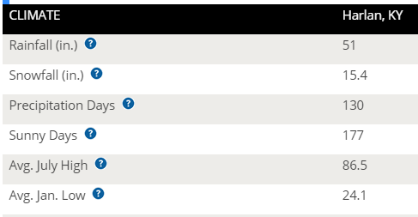 | Harlan County, KY, gets 51 inches of rain per year. The US average is 37. Snowfall is 15 inches. The average US city gets 25 inches of snow per year. The number of days with any measurable precipitation is 130.  On average, there are 177 sunny days per year in Harlan County, KY. The July high is around 87 degrees. The January low is 24. Our comfort index, which is based on humidity during the hot months, is a 43 out of 100, where higher is more comfortable. The US average on the comfort index is 44.

Colleges/universities with over 2000 students nearest to Harlan:
- Southeast Kentucky Community and Technical College
- Lincoln Memorial University
- Hazard Community and Technical College
- Walters State Community College
- University of the Cumberlands
- Tusculum College
- Northeast State Community College
Estimated median household income in 2013: $30,512 (it was $17,270 in 2000)

